|  |  |
| --- | --- |
| To: | Cabinet |
| Date: | 11 December 2024 |
| Report of: | Head of Financial Services |
| Title of Report: | Treasury Management Mid-Year Review for April – September 2024 |

|  |  |  |
| --- | --- | --- |
| Summary and recommendations | | |
| Purpose of report: | | To report on the performance of the Treasury Management function for the 6 months to 30 September 2024 |
| Key decision: | | No |
| Executive Board Member: | | Councillor Ed Turner, (Deputy Leader) Finance and Corporate Assets |
| Corporate Priority: | | A well-run Council |
| Policy Framework: | | Treasury Management Strategy |
| Recommendation(s): That the Cabinet resolves to: | | |
| 1. | Note the performance of the Treasury Management function for the six months to 30th September 2024 | |
|  |  | |

|  |  |
| --- | --- |
| Appendices | |
| Appendix 1 | List of investments as at 30th September 2024 |
| Appendix 2 | Risk Register |
|  |  |

# Introduction and Background

1. This report has been written in accordance with the requirements of the Chartered Institute of Public Finance and Accountancy’s (CIPFA) Code of Practice on Treasury and has been prepared in compliance with CIPFA’s Code of Practice on Treasury Management, covering the following:

* An economic overview for the first part of the 2024/25 financial year
* A review of the Council’s investment portfolio for 2024/25
* A review of the Council’s borrowing strategy for 2024/25
* A statement of compliance with Treasury and Prudential Limits for 2024/25

1. The Council operates a balanced budget, which broadly means cash raised during the year will meet its cash expenditure from a revenue perspective. Greater or lesser demand for cash generally is driven from capital activities. Part of the treasury management operations ensure this cash flow is adequately planned, with surplus monies being invested in suitable counterparties, providing adequate liquidity and security initially before considering optimising investment return.
2. The second main function of the treasury management service is the funding of the Council’s capital plans. These capital plans provide a guide to the borrowing need of the Council, essentially the longer term cash flow planning to ensure the Council can meet its capital spending operations. This management of longer term cash may involve arranging long or short term loans, or using longer term cash flow surpluses, and on occasion any debt previously drawn may be restructured to meet Council risk or cost objectives.
3. The Council held investments of £24.198 million (based on the investment value) as at 30th September 2024. Net forecast interest earned during the year, including from loans to companies, minimum revenue provision, and external borrowing, was £5.129 million against a target of £2.935 million, a favourable variance of £2.193 million.

**Economic Overview**

1. In the wider economy, the following factors formed the background to the overall economic position:

* Gross Domestic Product growth has been slow at 0.5% quarter on quarter;
* The Consumer Price Index measure of inflation briefly fell to the Bank of England’s target of 2% in June before moving back up to 2.2% in July and August;
* The Bank of England lowered interest rates from 5.25% to 5.0% in August and then maintained them at that level;
* 10 year gilt yields fell to 4.0% in September.

**Interest and Interest Rate Forecasts**

1. The Council employs Link Group as its treasury advisors and part of their service is to assist the Council to formulate a view on interest rates. Part of this advice includes a forecast of the Public Works Loan Board (PWLB) rates. The PWLB is a lending facility operated by the UK Debt Management Office (DMO) on behalf of HM Treasury and provides loans to local authorities. The PWLB rate forecasts below are based on the Certainty Rate (the standard rate minus 20 bps) which has been accessible to most authorities since 1st November 2012.
2. The latest forecast on 28 May (which has not needed to be updated since that point) forecasts that short, medium and long-dated interest rates will reduce over the next year or two, although there are risks of higher rates if inflation proves to be higher than expected and a continuing tight labour market.



# Investment Portfolio and Performance

1. The Council held investments of £24.198 million (based on the investment value) as at 30th September 2024. Net forecast annual interest earned during the year, including from loans to companies, minimum revenue provision, and external borrowing, was £5.129 million against a target of £2.935 million, a favourable forecast variance for the year of £2.193 million. This relates to the following factors:

Favourable

* General Fund Borrowing costs lower by £0.824 million due to long term borrowing on the General Fund not being required following slippage in the capital programme and including lower loan requirements from the Council’s Housing Companies due to internal borrowing.
* £1.274 million interest charged to the Housing Revenue Account (HRA) in lieu of external borrowing
* £0.590 million lower minimum revenue provision as a knock-on effect of lower General Fund capital expenditure and therefore lower associated prudential borrowing relating to those schemes.

Adverse

* Lower investment income by £0.111 million due to less funds being available to invest following the use of internal funds to finance prudential borrowing.
* £0.384 million lower net income from loans to the Council’s companies

1. Budgeted income from loans to OCHL and Oxwed for the year is £3.413 million. As at the 30th September 2024, forecast income for 2024/25 is £2.881 million, , an adverse variance of £0.532 million. Included in these assumptions is the expectation that the housing investment company loans will be repaid following transfer of the housing investment company properties to the Housing Revenue Account. This is included within the £0.384 million overall adverse variance on net income from loans to companies.
2. The delays in in the capital programme have resulted in no external borrowing being taken out to finance General Fund capital financing borrowing resulting in an anticipated favourable variance of £0.824 million against budget. This has meant that the HRA has not, as at 30th September, had to utilise external borrowing leading to additional internal borrowing forecast income of £1.274 million for the General Fund.
3. There are a number of factors giving rise to this overall position:

* Lower than anticipated lending to the Council’s companies resulting in lower income from the companies;
* The delays in in the capital programme and lower company debt have resulted in
  + General Fund borrowing being lower than anticipated and all General Fund borrowing relating to the financing of the 2023/24 capital programme being internal;
  + reduced minimum revenue provision charges following reduced prudential borrowing requirements; and
  + HRA borrowing relating to the financing of the HRA capital programme being able to be temporarily taken from available cash resources.

1. The beneficial impact to the Council of the treasury operations indicated by this report will be also be reported in the regular monitoring reports to the Cabinet.
2. The Treasury Management Strategy for 2024/25 was approved by the Council in February 2024; to date the Strategy has been fully adhered to. Prudential indicator information is not included in this report because it relies on a full year picture and, crucially, on capital activity which will not be known in full until the end of the financial year.
3. The Council aims to maintain as diversified an investment portfolio as possible whilst ensuring there are no policy and procedure breaches. There is limited scope for diversification when investment balances are low and there is more focus on short term borrowing to cover any short term cash shortages. Security of investments is always the primary concern when arranging investments with liquidity and yield being secondary, but key considerations.
4. The Council operates an approved counterparty listing which details all institutions with whom the Council may invest, the maximum amount which may be invested with any single counterparty group at any given point and the maximum duration period. The counterparty list is set in association with recommendations from Link Asset Services although ultimate authorisation of approved counterparties rests with the Section 151 Officer. The list is actively managed and reviewed on a weekly basis or more regularly if required.
5. Monthly monitoring meetings are held with the Section 151 Officer, Financial Accounting Manager and treasury staff to discuss investments in terms of counterparties and maturity dates, cash flow, interest and borrowing rates and treasury operational and strategic strategies.
6. The strategy also adopts an ethical approach to investments, summarising that:

*“The Council will not knowingly invest directly in businesses whose activities and practices pose a risk of serious harm to individuals or groups, or whose activities are inconsistent with the Council’s mission and values. This would include, inter alia, avoiding direct investment in institutions with material links to:*

* *Human rights abuse (e.g. child labour, political oppression)*
* *Environmentally harmful activities (e.g. pollutants, destruction of habitat, fossil fuels)*
* *Socially harmful activities (e.g. tobacco, gambling)”*

1. The current approach to Environmental & Social governance (ESG) is to weigh up ESG criteria when choosing new investment providers as one of the matters that the Council considers, however under the Treasury Management Code, Security, Liquidity and Yield factors have to be prioritised. ESG criteria are used as an overlay to this.
2. The Council regularly reaches out to its current investment providers to seek a breakdown of their ESG principles and provide any information they have on their ESG credentials and investment partners are regularly questioned on their policies when the Council meet with them to discuss its investments and, where necessary, to apply what pressure the Council can to improve their ESG position.
3. It should be noted that ESG information is not always available and not always consistent across counterparties.

# Pooled Investment Funds

1. The Council currently has £15.863 million invested in 4 separate pooled investment funds. The higher level of interest rates has put pressure on capital values, but the revenue return is being maintained at expected levels.
2. Changes to the accounting rules on pooled investment funds means that the principal gain or loss will now be charged to the Surplus or Deficit on the Provision of Services, within the Council’s Income and Expenditure Account, rather than being held on the balance sheet. Following consultation, the government has introduced a mandatory statutory override for local authorities to reverse out the effect for five years from 1st April 2018. A further consultation extended the override for an additional two-year period until 31 March 2025 after which surpluses as well as deficits will impact on the Councils revenue position. Given the fluctuations in the property and money markets there is high of risk of some adverse revenue impact when the overrides are removed and consequently the Council holds an earmarked reserve against this risk. The position continues to be closely monitored.

# Property Investment Funds

1. At present, the Council has placed investments with two property funds; CCLA Investment Management, which is a property fund that limits its investors to Charities, Churches and Local Authorities and Lothbury Investment Management, a specialist UK property fund manager with a range of funds providing high quality exposure to different property sectors. Property values have recovered from the shock of the Covid Pandemic and are still giving the Council a good return on its investments. Both property funds have reduced their retail holdings which de-risks the capital value they hold.

**CCLA Investment Management Limited**

1. The Council has held a £3 million investment in the CCLA fund since September 2013. The investment has produced quarterly revenue returns ranging between 5% and 6% and it is expected that the Fund will continue to achieve rates in this region.
2. Additionally, the value of the Council’s investment with CCLA has appreciated from £3 million to £3.515 million as at 30th September 2024, equating to growth of 24.86% to date from inception. However, the values of the individual unit prices have fluctuated over time and the effect of capital appreciation (and depreciation) is illustrated in the graph below. There has been pressure on the overall property value but the dividend is being maintained and prices are always going to fluctuate over time. This is seen as a long term investment and the returns over the holding period are significantly more than if the council had invested in standard counterparties

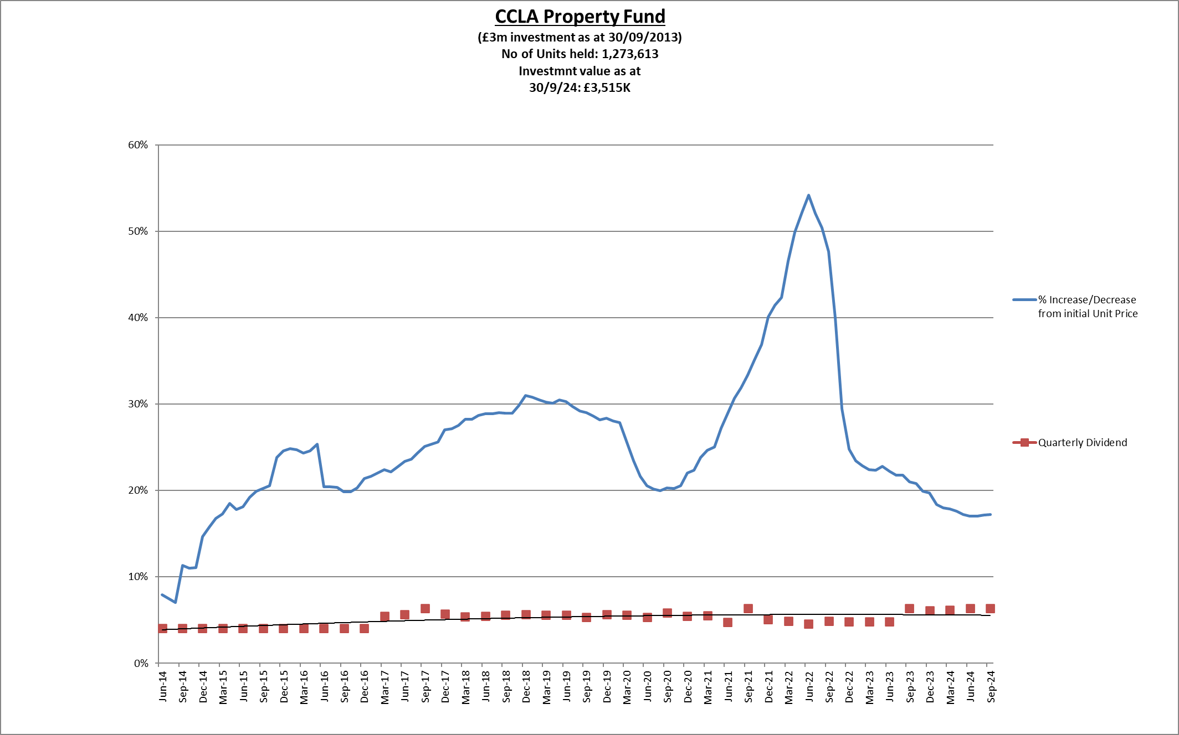

1. The investment returns around £45k revenue per quarter.

**Lothbury Investment Management**

1. Due to restructuring within the Lothbury IM fund, Oxford City Council decided to exit the fund along with many other investors and now the fund is being wound up. The fund is being repaid to investors on a pro rata basis as the fund sell assets, so far the council has received £3.630 million resulting in a capital loss of £0.507 million, it is expected that once the remaining investment is paid back the total capital loss will be circa £0.860 million.
2. The returns on the investment in this fund that the Council has received over the period of its investment are £1.460 million higher than if the Council had invested at the Bank of England base rate over the same period. The Council continues to receive dividend payments until the capital is fully repaid.
3. Funds have been set aside in earmarked reserved to offset the expected capital losses.

**Multi-Asset Funds**

1. The Council has invested in two multi asset funds as set out in the treasury strategy, Multi-asset funds are able to invest across the investment landscape and may include equities, bonds and cash. This provides a greater degree of diversification than investing in a single asset class. The same accounting rules apply to multi-asset funds as apply to property funds.

**Artemis Multi Asset Fund**

1. £5 million is invested into the Artemis multi asset fund. Since inception the capital value has increased to £5.456 million equating in a rise of (9.14)% with an average monthly dividend payment of £20k giving an average percentage return of 4.84%. Capital values should improve when interest rates fall further.

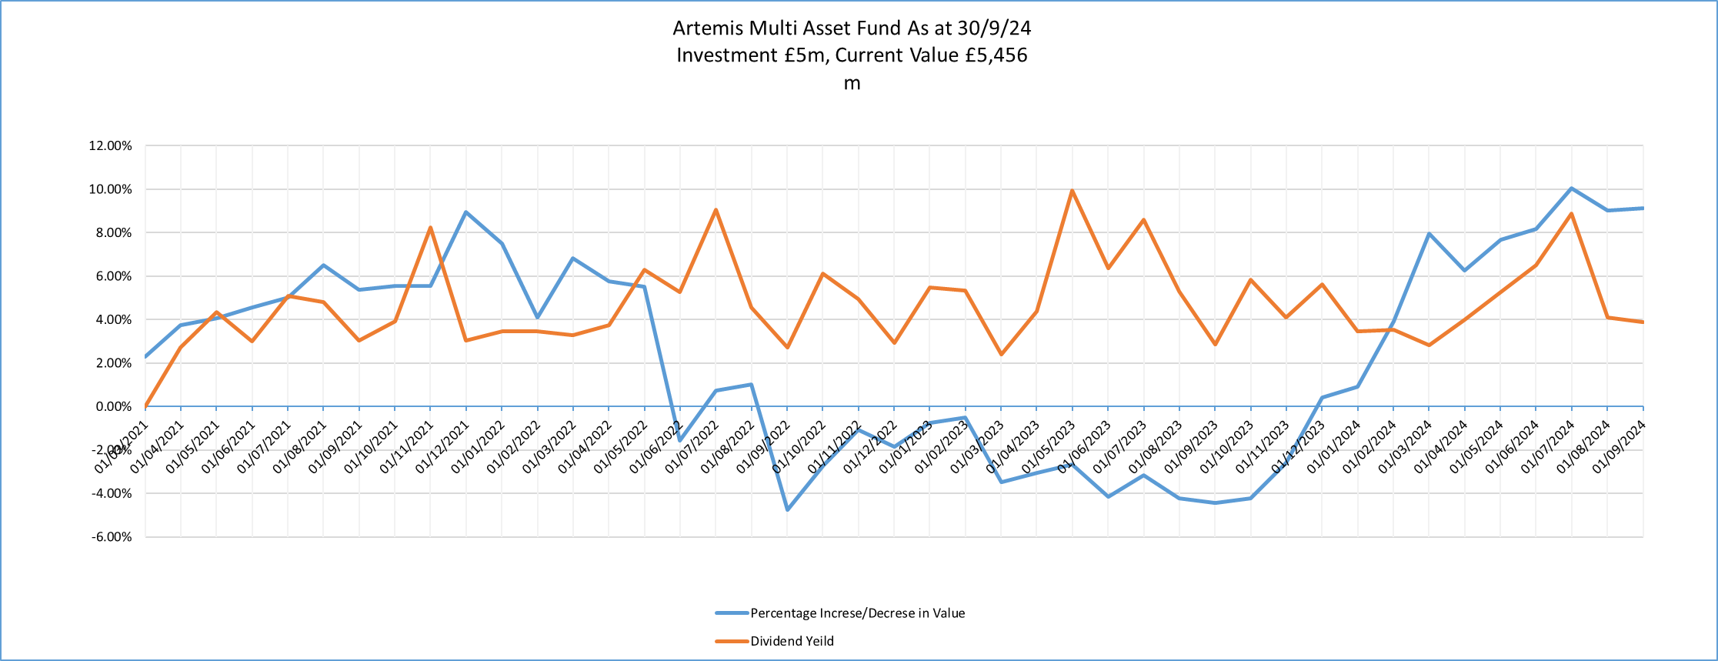

**Fidelity Multi Asset Fund**

1. In accordance with the 2020/21 budget and in line with the treasury strategy, £5 million was invested into the Fidelity multi asset fund. Since inception the capital value has fallen to £4.077 million equating to a fall of (18.45) % with an average monthly dividend payment of £19.9k giving an average percentage return of 4.78%.
2. The reasons for the fall are predominantly due to falls in the stock market which are driven by [inflation](https://www.fidelity.co.uk/markets-insights/personal-finance/personal-finance/next-month-will-squeeze-your-finances/), rising interest rates, and an increase in energy costs made worse by Russia’s war in Ukraine. Capital values should improve as interest rates fall.

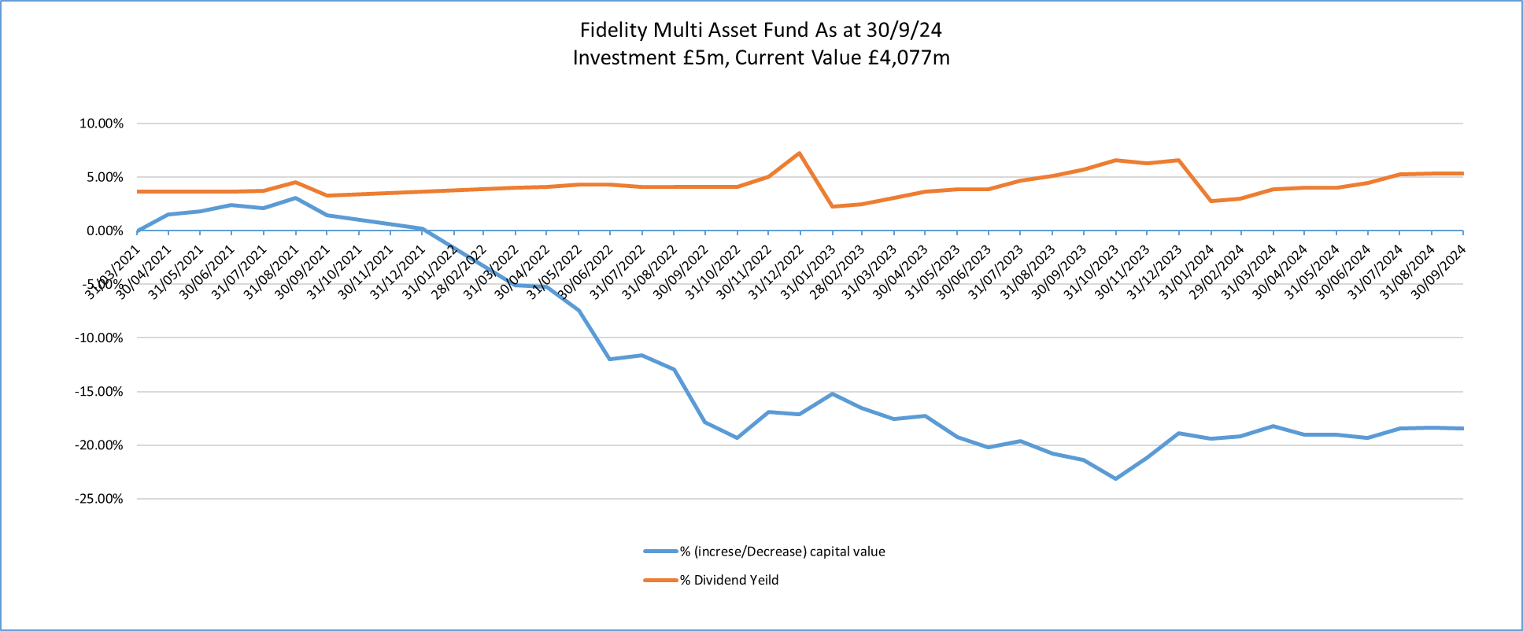

**Funds Overall position**

1. Although the capital value of the multi asset funds and the property funds has been volatile These investments add diversity to the overall investment portfolio. Although the values may fluctuate in the short term the funds are seen as long-term investments that provide a good return.

**Investment Portfolio**

1. As at 30th September 2024, the Council’s total investment portfolio amounted to £24.2 million, with £5.9 million of this being held in property funds, £10 million in Multi asset funds and £8.335 million being held in instant access cash facilities in order to manage day to day cash flow requirements. A breakdown of these investments is shown at Appendix 1.
2. The graphs below illustrate how the Council’s investment portfolio is distributed, both in terms of the type of investment and counterparty category:

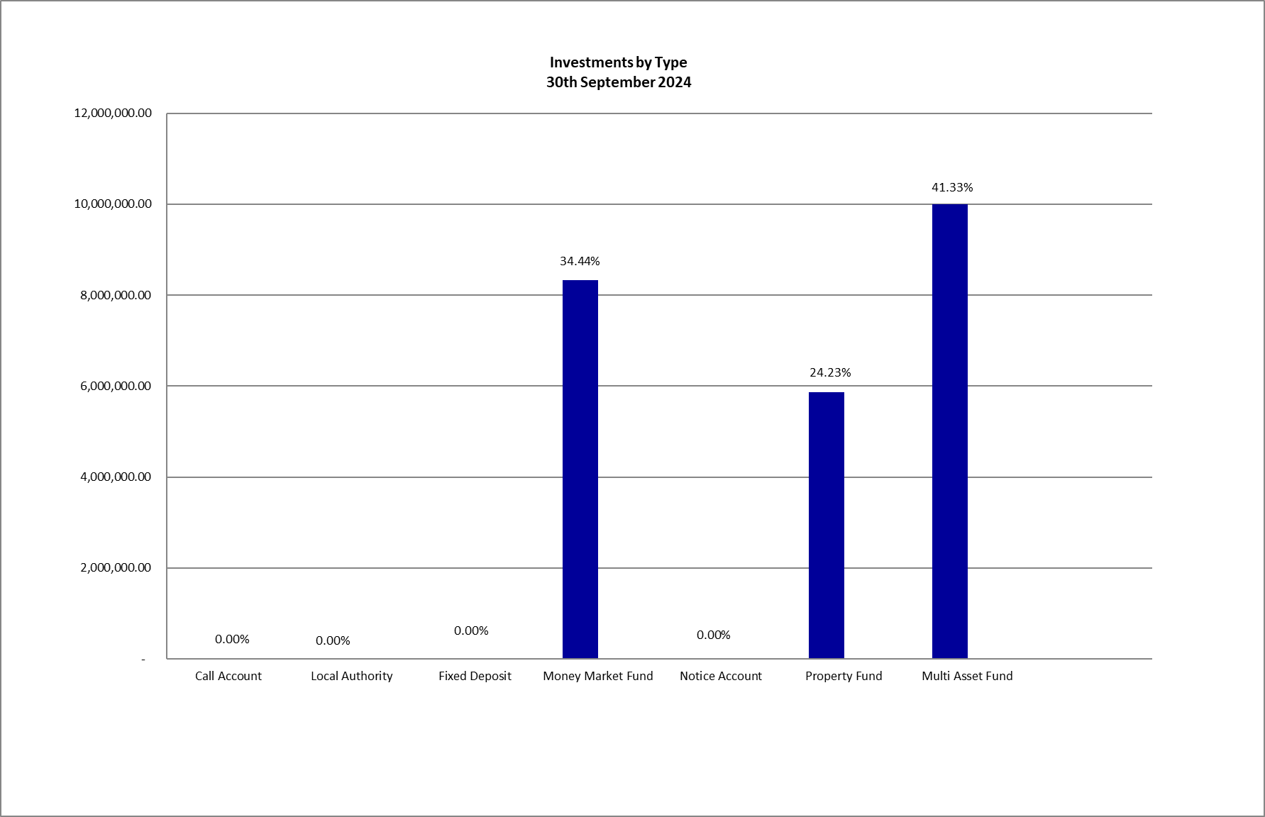

1. Fixed deposits and certificates of deposits both have an agreed start and end date which are arranged where possible, to suit the cash flow requirements. However, due to the low overall levels of investment funds, spare funds are currently held in instant access funds.
2. The Council’s Treasury Management Strategy (‘the Strategy’) limits non-specified investments to 25% of the previous year’s average investment portfolio or £25m whichever is greater. This limit is reviewed each year when setting the Strategy in order to ensure a balanced and diversified portfolio of investments. Property funds and investments in excess of 364 days are classified as non-specified due to the associated risk; property funds by nature are high risk due to the volatility of the market. There are several factors that deem longer term investments to be more risky in nature including the risk of interest rate rises and the commitment of cash for longer periods.
3. In addition to the above the Council has £10 million invested in the National Homelessness Property Fund, as a service rather than a treasury investment, which has property in Milton Keynes, Bristol and Oxford. Resonance developed the Property Fund with leading homelessness charity St Mungo’s. It is the largest impact investment fund in the UK and closed at nearly £57m. The Fund design was developed in response to the lack of private rented accommodation accessible to rising numbers of people living in temporary accommodation or otherwise at risk of homelessness in London. There is also £4 million invested in a second National Homelessness Property Fund which widens the area covered by the funds. These are classified as service investments undertaken using service delivery powers rather than treasury powers under Section 12 of the Local Government Act 2003. This means the counterparty limit for the £14 million loaned to the National Homelessness Property Funds is not taken into account when assessing the residual headroom available for investment in non-specified investments.
4. The Strategy defines a specified investment as one that is in sterling, less than one year in duration or, if it is a year or more, can be repaid earlier on request and with counterparties that meet the Council’s credit rating criteria. Additionally, once the duration of a non-specified investment falls below 365 days, it also falls into the Specified category. Currently due to internal borrowing the Council only has scope for money market fund deposits which can be called on immediately so liquidity is maximised and the Council doesn’t hold any investments with more than a month’s duration.

**Investment benchmarking**

1. At the last Finance and Performance Panel a comparison of the Council’s investment performance compared to its peers was requested, including a comparison of the associated risk levels of those investments. This section has been included in the report as a response to that request. Each quarter the Council receives a benchmarking report from its advisors Link Asset Services (‘Link’). This compares the Council’s performance to peers by interest percentage and risk. The results of this are summarised over time in the table below.
2. Link provide investors with a suite of approved counterparties rated by them for credit risk and suggest a suitable maximum duration. The risk taken by authorities in the benchmarking group is calculated by ranking the approved counterparties and investment types provided by Link and taking into account duration of investments coming up with a rating between 1 which is lowest risk and 7 which is the highest.
3. At present Oxford City Council’s cash position is lower than it has been in past years due to the use of internal funds to finance prudential borrowing and liquidity has become one of the most important factors, meaning that the Council has mainly been limited to short term money market deposits which have a low credit risk, and, because they are immediate access, are low risk from a duration perspective.
4. Although the Council is receiving low investment interest returns yield due to reduced investment balances this is offset by the reduced need for external borrowing and the costs associated with that.
5. As can be seen from the chart below, Oxford City Council historically has performed well in terms of investment returns whilst generally maintaining the risks associated with those investments at a lower level than its peers.



**Borrowing**

1. The Council has not taken on any additional long term debt during the year to date and so the balance of its external borrowing remains at approximately £218.5 million. This figure relates to funds borrowed from the PWLB to buy out the Housing Revenue Account (HRA) from the subsidy system and additional borrowing to externalise HRA borrowing used to finance the capital programme. External debt currently relates wholly to Housing with interest repayments being met by the HRA. The Council does not consider that debt restructuring and/or premature repayment would be financially advantageous.
2. The Council is currently managing other capital financing requirements through internal cash resources and short term treasury activity. However external borrowing will be necessary in the future to meet its capital expenditure requirements, and more external borrowing, also on the HRA, is expected to be taken out in the second half of 2024/25 and continuing into 2025/26.

**Treasury and Prudential Limits for 2024/25**

1. The Council has operated all of its Treasury Management activity within the parameters set by the Treasury and Prudential indicators in the Treasury Management Strategy for 2024/25.

**Other Key Updates**

**Changes in Risk Appetite**

1. The 2018 CIPFA Codes and guidance notes have placed enhanced importance on risk management. Where an authority changes its risk appetite e.g. for moving surplus cash into or out of certain types of investment funds or other types of investment instruments, this change in risk appetite and policy should be brought to members’ attention in treasury management update reports. The Council has not made any significant changes to its investment approach at this time. The risk will continue to be managed by understanding the individual investment vehicles and also by considering the appropriate percentage of non-specified investments that can be held in the overall portfolio.

# Treasury Advisor

1. Treasury advice and market information is provided by Link Asset Services. The most recent procurement process reappointed Link Asset Services as the Council’s treasury advisors for an initial period of 3 years from 1st November 2023 with the ability to extend by two further periods of 2 years each. Information provided by Link Asset Services is used to advise council officers when making investment decisions.

# Financial Implications

1. Any financial implications are contained within the body of this report.

# Legal Issues

1. The Council is required by regulations issued under the Local Government Act 2003 to produce and consider this treasury management monitoring report. This meets the requirements of both the CIPFA Code of Practice on Treasury Management, (the Code), and the CIPFA Prudential Code for Capital Finance in Local Authorities, (the Prudential Code).

# Level of Risk

1. There are no risks in connection with the report’s recommendations. A risk register covering Treasury Management activity is included at Appendix 2. One key risk going forward is around uncertainty caused by interest rate changes from the Bank of England and the effect this will have on the economy. These changes are being driven by the overall economic position both at the national and the global level. Equally it is uncertain how long interest rates will remain high before coming back down. This gives uncertainty around both investment and borrowing decisions. There are also risks that there will be failings in investment counterparties although this risk is reduced through the use of counterparty lists. Risk assessment and management is a key part of Treasury Management activity, especially in the selection of counterparties when investment is being considered and in the timing and duration of any borrowing being planned. The Council uses external advisors and counterparty credit ratings issued by the rating agencies to assist in this process.

# Equalities Impact

1. The Council follows an ethical investment policy, investment interest helps provide council services, which has a beneficial equalities impact.

|  |  |
| --- | --- |
| **Report author** | Bill Lewis |
| Job title | Financial Accounting Manager |
| Service area or department | Financial Services |
| Telephone | 01865 252607 |
| e-mail | blewis@oxford.gov.uk |

|  |  |
| --- | --- |
| Background Papers: None | |
| 1 | Or - list all background papers |
| 2 |  |
| 3 |  |
| 4 |  |